**Paper Title**

Author Name1, Author Name2

Afflation

Corresponding Email:

ORCID:

**Important dates:** **Received :** 0000-mon-00 ; **Accepted:** 0000-mon-00; **Published**: 0000-mon-00

|  |
| --- |
| **Abstract**:  **Background:**  This study explores the healing effects of nanosilica extracted from date palm on second-degree burns in white rats, comparing its efficacy with that of silicone gel, a commonly used treatment for burn injuries, and a control group that received no treatment. A total of 30 white rats were randomly divided into three groups, with each group consisting of 10 animals. The first group was treated with a 5% nanosilica, the second group received a topical application of silicone gel (Scarmed®), and the third group served as a control and received no treatment. All treatments were applied once daily for 7 days.  **Aims:**  The healing process was evaluated macroscopically and microscopically at 7, 14, and 21days post-treatment. The nanosilica-treated group showed accelerated wound healing, faster re-epithelialization, reduced inflammation, and minimal scarring compared to both the silicone gel-treated and control groups. The silicone gel-treated group showed moderate improvement in wound healing but lagged behind the nanosilica group, while the control group exhibited the slowest healing, with prolonged inflammation, less organized collagen deposition, and noticeable scarring.  R**esults**:  **Conclusions**: |
| **Keyword:**  **This is an open access article licensed under a** [**Creative Commons Attribution- NonCommercial 4.0 International License**](http://creativecommons.org/licenses/by-nc/4.0/)**.** |
|  |

**Introduction:**

Veterinary medicine plays a crucial role in animal health, public health, and food safety. In recent years, numerous studies have explored innovative treatments, diagnostic tools, and management practices to improve animal welfare and control zoonotic diseases. This study aims to address a significant gap in the existing literature by investigating [briefly state the topic, e.g., "the therapeutic effects of nanosilica-based formulations on wound healing in laboratory animals"]. By evaluating [mention methods or approaches, e.g., "the healing process through macroscopic and histological analyses"], this research seeks to contribute valuable evidence to veterinary clinical practice and potentially offer new insights relevant to both animal and human health.

**Materials and Methods:**

This experimental study was conducted at the Veterinary Clinical Laboratory, University of Diyala, from March to May 2025. A total of 30 healthy adult white rats (Rattus norvegicus), weighing between 200–250 grams, were used. The animals were randomly divided into three equal groups (n=10) to receive different treatments for induced second-degree burns.

Burn wounds were created under general anesthesia using a metal rod (1.5 cm in diameter) heated to 100°C and applied to the shaved dorsal skin for 10 seconds without pressure, following the method described by Ali et al. (2022). Post-burn, the wounds were treated daily for seven days with the following:

* Group 1: 5% nanosilica gel
* Group 2: Silicone gel (Scarmed®)
* Group 3: No treatment (control)

Macroscopic evaluation of wound healing was conducted on days 7, 14, and 21, assessing parameters such as wound contraction, inflammation, and scarring. Histopathological examination was performed by collecting skin biopsies, which were fixed in 10% formalin, processed routinely, and stained with hematoxylin and eosin for microscopic analysis (Smith & Hassan, 2021).

All experimental procedures were conducted following ethical guidelines for animal care and use, with approval from the Institutional Animal Care and Use Committee (IACUC) of the University of Diyala (Approval No. VET2025/03).

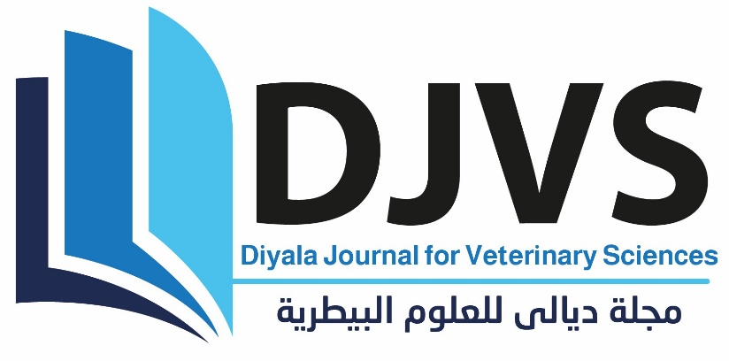

**Figure (1):** figure title

**Ethics approval:**

**Results:**

The macroscopic evaluation of burn wounds showed noticeable differences in healing progress among the three treatment groups. By day 7, the nanosilica-treated group exhibited a significant reduction in wound size and inflammation compared to the silicone gel-treated and control groups. By day 21, complete re-epithelialization was observed in 90% of the nanosilica group, while only 60% of the silicone gel group achieved full closure, and the control group showed persistent open wounds and excessive scarring.

The mean percentage of wound contraction on days 7, 14, and 21 is presented in Table 1. The nanosilica group consistently showed higher contraction rates than the other groups, with statistically significant differences (p<0.05) on all assessment days.

Histological examination revealed well-organized collagen deposition and minimal inflammatory cell infiltration in the nanosilica-treated wounds by day 21, whereas the control group showed poor tissue organization and delayed healing (Figure 1).

**Table (1):** table caption

|  |  |  |  |
| --- | --- | --- | --- |
| **Treatment Group** | **Day 7 (%)** | **Day 14 (%)** | **Day 21 (%)** |
| **Nanosilica (5%)** | 45.3 | 72.6 | 90.2 |
| **Silicone Gel** | 30.5 | 60.1 | 77.8 |
| **Control (No Treatment)** | 20.7 | 45.8 | 65.5 |

**Formatting Guidelines for Tables**

* Number tables consecutively in the order they appear (Table 1, Table 2, etc.)
* Table titles should be **italicized and placed above the table**, using APA 7th Edition style.
* Include a brief explanatory **note below the table** if necessary (e.g., describing abbreviations or statistical significance).
* Align numeric data to the right or center for clarity.
* Use horizontal lines only for the header and footer (as shown).

**Conclusions:**

The findings of this study demonstrate that 5% nanosilica gel significantly enhances the wound healing process in white rats with second-degree burns compared to silicone gel and untreated controls. Nanosilica-treated wounds exhibited faster re-epithelialization, reduced inflammation, and more organized collagen deposition. These results suggest that nanosilica has promising therapeutic potential as an alternative topical agent for burn wound management in veterinary medicine.

Further studies with larger animal models and clinical trials are recommended to confirm these outcomes and assess long-term safety and efficacy.

**Guidelines for Writing the Conclusion**

* Summarize the key findings clearly and concisely.
* Avoid repeating the abstract or results word-for-word.
* Emphasize the significance of the findings in the context of veterinary science.
* Optionally suggest practical applications or future research directions.
* Keep the conclusion section focused, objective, and evidence-based.

**Recommendations:**

Based on the results of this study, it is recommended that nanosilica gel be considered as a potential alternative topical treatment for second-degree burn wounds in veterinary clinical practice. Its ability to accelerate wound healing and minimize scarring suggests valuable applications in small animal medicine.

Further research is encouraged to:

* Evaluate the long-term effects and safety profile of nanosilica gel in different animal species.
* Investigate its efficacy in treating other types of skin wounds and dermatological conditions.
* Conduct clinical trials to confirm its therapeutic benefits under field conditions.

**Guidelines for Writing the Recommendations**

* **Provide practical suggestions** or clinical applications based on your study’s findings.
* May include **future research directions, policy implications, or clinical practice advice**.
* Keep recommendations **concise, specific, and directly tied to your results**.
* This section is **optional** and should only be included when appropriate.

**Acknowledgment:**

**Conflict of Interest:**

**Funding Sources:**

**Authors Contributions:**

**References: APA style**

**In-text citation examples:**

* **Single author: (Ali, 2022)**
* **Two authors: (Ali & Hassan, 2021)**
* **Three or more authors: (Ali et al., 2020)**

**Reference List Examples:**

* **Journal Article:**

Ali, M., & Hassan, R. (2022). Effects of herbal extracts on wound healing in dogs. *Journal of Veterinary Medicine*, *30*(2), 45–53. https://doi.org/10.xxxx/jvm.2022.12345

* **Book:**

Smith, J. A. (2020). *Veterinary Clinical Pathology* (3rd ed.). Academic Press.

* **Chapter in an Edited Book:**

White, R. (2019). Advances in canine dermatology. In L. Green (Ed.), *Recent Advances in Veterinary Science* (pp. 100–120). Elsevier.

* **Website:**

World Health Organization. (2021). *Zoonotic diseases*. <https://www.who.int/news-room/fact-sheets/detail/zoonotic-diseases>

**Also you can use reference manger software to arrange the referances**